**Name: Faizan Nazir**

**Arid No: 19-ARID-5157**

**Program: BSCS7A**

**Course: Parallel and Distributed Computing**

**Assignment No: 01**

**Teacher Name: Ms. Sadia Zar**

**Q: Write a difference between Parallel and distributed computing?**

**Ans:**

**Parallel Computing:**

In Parallel Computing multiple processors (of 1 computer) performs multiple tasks assigned to them simultaneously (asynchronously). Memory in parallel system can either be shared 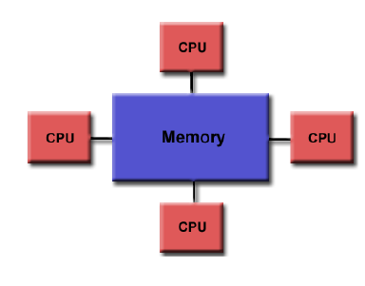or Distributed 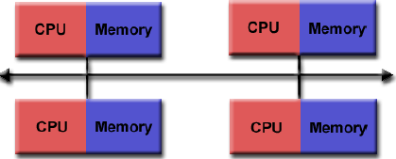. Parallel Computing provide concurrency and saves time and money. All stand-alone computers today are parallel from a hardware perspective.

**Distributed Computing:**

In Distributed Computing we have multiple autonomous computers which seems to the user as single system. In distributed systems there is no shared memory and computers communicate with each other through message passing. In distributed computing a single task is divided among different computers.

Distributed computing is commonly used by organizations such as Facebook and Google that allow people to share resources

**Difference between Parallel Computing and Distributed Computing:**

|  |  |  |
| --- | --- | --- |
| **Index** | **Parallel** | **Distributed** |
| 1 | Multiple Processors Performed Multiple Tasks | Multiple computers perform multiple Tasks |
| 2 | Processors communicate with each other through Bus | Computers communicate with each other through message passing. |
| 3 | Single Computer is required | Multiple Computer Required. |
| 4 | It may have shared or distributed memory | It only has distributed memory |
| 5 | Multiple processors execute multiple tasks simultaneously in parallel computing | Many computer systems execute tasks simultaneously in distributed computing |